Kappa Consulting is a boutique consulting firm, operating in London, U.K.. They employ a small team of 5 consultants and 10 analysts who over the years have become very adept at working together; the analysts have become skilled at understanding the requirements of the consultants, and can prepare analyses and reports to their specifications. The firm has a small set of clients who value and trust the consultants. On a recent trip to Bengaluru in India, the CEO met up with a former MBA classmate who tells him that he runs a Knowledge Process Outsourcing outfit, that employs graduates with talents and skills comparable to Kappa’s consultants, but with wages 40% lower than what Kappa pays its analysts. He recommends that Kappa offshore and outsource analytics work to his unit, and so cut costs in the London operations, and instead scale up its consultants. What should the CEO do?

Outsourcing occurs when an organization hands over part of the value chain it owns to a different firm, while maintaining the number of business it is active in. In contrast, a divestiture occurs when the firm reduces the number of businesses it is active in by completely pulling out of a value chain and ceasing to offer the products from that value chain to the relevant customers. In other words, in outsourcing, the firm continues to offer the products and services based on inputs from the outsourced value chain activities to the relevant customers, but these parts of the value chain are no longer done in-house.
Offshoring occurs when part of a value chain moves to another geography, usually one with lower cost. Offshoring may or may not involve outsourcing. The same firm could merely relocate operations to a new location (see Figure 9.1). Thus decisions on whether to move the process out of the firm’s boundary as well as out of the current geographical boundary occur together, if only implicitly (i.e., we may be implicitly choosing not to offshore, when we outsource to a local vendor).

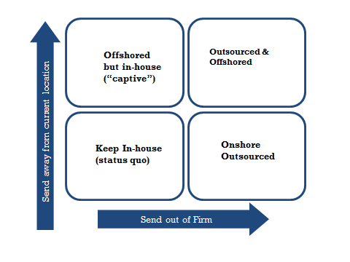
Figure 9.1: Outsourcing and offshoring

The canonical outsourcing situation is one where before a company owned an entire value chain and afterwards, only parts of it. For example, a company active in the footwear business can outsource manufacturing while continuing to do design and distribution, see Figure 9.2. The key question therefore is whether manufacturing and design / distribution need to be owned in the same corporate portfolio. This is the outsourcing decision. It does not involve asking whether the company should get out of the footwear business, which is the divestiture decision. Note that just the manufacturing of footballs can be seen as a business by itself, since it has its own business model (i.e., answers to the question of who is the customer, what is the value proposition, and how is this delivered). But for clarity, in this document we will refer to it as a value chain activity as seen from the perspective of a firm that begins by owning the entire business (i.e., manufacturing, design and distribution). Thus outsourcing involves refocusing by exiting value chain activities that are parts of the businesses in the portfolio, whereas divestiture involves refocusing by exiting the entire set of value chain activities that constitute a business in the portfolio.

A further distinction between divestiture and outsourcing is that under outsourcing there remains an ongoing dependency between the outsourced value chain activities and those that are kept in-house. Such ongoing dependency may or may not be the case after divestiture. Despite these differences, we can analyze the outsourcing decision in a broadly similar way to divestiture, because both involve refocusing (see box 9.1).
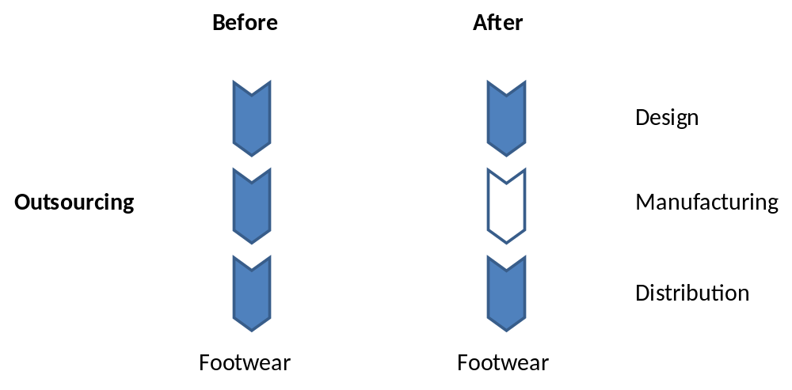
Figure 9.2: The company remains in the footwear business after outsourcing manufacturing

Box 9.1 The Outsourcing Test
The outsourcing test can be written as:
V_{O}[A] + O[B] > V[AB]

Let’s say a company is active in a business, of which it considers outsourcing some steps of the value chain (B) while keeping the rest in-house (A). In the footwear example, B is manufacturing, and A represents the rest of the value chain, i.e. design and distribution. Then, V[AB] is the (net present) value of the business when the value chain activities are jointly owned, as in the status quo. V_{O}[A] + O[B] refers to the value of the business after outsourcing, in which V^{O}[A] is the value of the business comprising retained value chain activities and O[B] is the value realized from the outsourced value chain activity B. O[B] is the value for the original owners, which may be realized over time through a contractual agreement with the vendor who takes B from the company.

From the outsourcing test it follows that a corporate parent should outsource value chain activities B for one or both of the following reasons:

- Failing the synergy test
If value chain activity B no longer benefits from being jointly operated with value chain activity A, then it’s time to outsource value chain activity B. Suppose that synergies are absent (i.e., V(AB) ≤ V(A) + V(B)). Then as long as the change in ownership does not destroy value, then a failure to pass the synergy test (i.e. V(AB) ≤ V(A) + V(B)) is sufficient to pass the outsourcing test. An ownership change could destroy value of the unit that is outsourced (i.e., O[B] < V[B]) if key people would leave the unit or if the unit is transferred to the new owner without proper compensation to the original owners (e.g. an upfront payment or guaranteed lower prices for a fixed period). The remaining units could suffer (i.e., V_{O}[A] < V[A]) if the inputs received from B are worse than before.

The synergy test may fail even though it used to pass earlier. For instance, the inputs provided by business B to business A have become standardized so that ongoing collaboration is no longer needed. The synergy test may also fail because of dis-synergies, for instance, missed opportunities for B to sell to A’s rivals, or because of poor management of B by A’s managers as it is not seen as important enough to merit attention.

- A vendor can do better than the in-house unit
More typically in outsourcing situations, the synergy test is likely to be passed, possibly with Connection and/or Customization synergies. If value chain activity B is better off with a different corporate parent than the current one, then it’s time to outsource this activity. This might be the case even if the synergy test is being passed. Thus, even if there are gains from jointly operating businesses A and B such that V(AB) > V(A) + V(B), and even if V_{O}[A]) < V[A]), as long as O[(B] >> V[B] (i.e., if you can get a lot of value out of outsourcing parts of the business to a vendor, because the vendor is a specialist, or can exploit synergies with her other businesses), then you should still outsource.

It should be clear that O[B]—the value realized by handing over business B to a vendor—plays a critical role in this decision. The larger it is, the more likely it is that the outsourcing test will be passed. O[B] itself depends on how much value the vendor creates when running the value chain activities that comprise B when B is under their portfolio, compared to the value from operating it as a separate stand-alone business V[B].

A specialist vendor often will be able to create significant value when running B as part of its portfolio, compared to when B is stand-alone, because of advantages relating to efficiency, effectiveness, and flexibility (see Figure 9.2). Efficiency implies the vendor can do it cheaper, and effectiveness implies they can generate higher willingness to pay. Flexibility benefits for the client refers to the ability to convert fixed to variable costs, making the performance of the client firm less dependent on market conditions (i.e., lowering systematic risk). The vendor on the other hand can balance demand across multiple clients.

Put simply, while value chain activity B may not be one in which you can establish any competitive advantage (it’s not “core” for you), it is one where a specialist vendor can do so (it is “core “ for them). The value unlocked by passing on B to an external specialist vendor (instead of doing it in-house) can be shared with the vendor through an agreement, so that all else being equal, the greater the value the vendor can create, the larger O[B] will be. This is the essence of the outsourcing decision, also known as the “Make or Buy” decision.

. 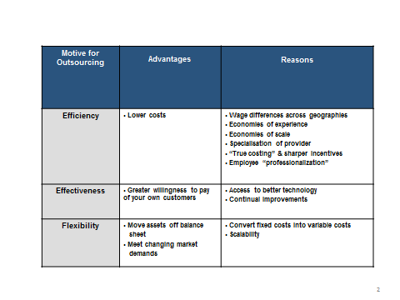
Figure 9.3: Why a specialist vendor can create more value after taking over parts of your value chain

However, because outsourcing involves an ongoing contractual provision of inputs from B to A between two independent firms, we must also be particularly mindful of transaction costs. As we discussed in Section 3, real world contracting is inescapably incomplete: every eventuality cannot be foreseen, even the costs of trying to agree upfront on clauses to cover as many eventualities as possible are not small, and having the contract enforced in a court of law is not always easy or cheap. Honest misunderstandings and mis-communications are also likely. This creates potentially large transaction costs between parties to a contract. These transaction costs can eat into the synergies between value chain steps A and B.

When outsourcing occurs despite the existence of synergies between A and B, we must therefore be concerned about transactional hazards in the relationship. (If there are no synergies, then the impact of transaction costs will largely be restricted to the fixed cost of finding and negotiating with the vendor, as other transaction costs are a proportion of potential gains from synergies.) Thus a key issue in outsourcing is to verify whether the potential gains from outsourcing to a specialist vendor will be offset by the transaction costs of dealing with that vendor. These choices are summarized in Figure 9.4.

 | Synergy test (with retained value chain activities):  Pass | Synergy test (with retained value chain activities):  Fail
Can the vendor manage these value chain activities better?  Yes | Outsource if transaction costs are not too high, else keep in-house | Outsource
Can the vendor manage these value chain activities better?  No | Keep in-house | Outsource
Figure 9.4: When to outsource

When synergies exist between A and B, they are likely to be of the Customization and Connection variety, as these synergies are most relevant in the ongoing relationship between the distinct activities underlying A and B. The other two synergies, Consolidation and Combination, involve similar resources, which are unlikely to be relevant here because A and B are different value chain steps (see Section 2). Further given our understanding of governance costs (see Section 3), we might reasonably expect that in general Customization based synergies between A and B would result in higher transactional hazards (because substantial modification is required, and can lead to “hold-up” by the vendor) than Connection synergies. This suggests caution in outsourcing when Customization synergies are involved, even if a specialist vendor promised a very high O[B]. In contrast, if the synergies are of the Connection type (which do not require modification), outsourcing should be easier.

To make the assessment of transaction costs more concrete, let us consider the case of outsourcing services, which may perhaps be the most complex form of outsourcing. Increasingly, the outsourcing of services goes hand in hand with offshoring. We can distinguish among three categories of transaction costs in the outsourcing (with or without offshoring) of services to consider:
Contracting costs: These are the costs of selecting vendors, negotiating, and reaching agreement on contractual deliverables, designing and implementing monitoring, measurement and dispute resolution mechanisms. Because services are intangibles that are produced and consumed simultaneously, and depend on the human capital of producers, it is useful to consider separately two sub-categories of the transactional hazards associated with failures of coordination.
Transition Costs: These are the costs of knowledge capture and transfer from one set of personnel to another, as well as the costs of severance, retraining, and employee relocation. Much knowledge is embedded in people and social relationships, and such knowledge is difficult to transfer to vendors or captive organizations. Transition costs involve incentivizing employees to share knowledge, transferring knowledge, creating documentation, etc. While these may be always large (e.g., even when offshoring without outsourcing), they may be even larger when transition occurs to non-employees.
Interaction Costs: These are the cost of managing interactions between the outsourced (and offshored) processes and the processes remaining within the original location within the firm. Once the process is moved it needs to function in-sync with the other related processes retained in-house, and costs arise from the need to manage interactions between the process and context. The outsourcing of business processes involves substantial coordination; the client and vendor employee may need to interact continuously during the “production” of the service. Interaction costs involve costs such as ongoing process mapping and interface design, travel and communication, and coordination mistakes. Again, while these may be always large (i.e. even with offshoring without outsourcing), they may be even larger when interactions occur with non-employees.
Suppose the assessment of transaction costs suggets they are likely to be high this does not mean that we must necessarily decide against outsourcing. Some other options to consider include:

Dealing with high contracting costs
- Define better Service Level Agreements and metrics that are easier to verify and measure by both parties, and if necssary by a court
- Maintain partial ownership over supplier, for instance through a minority equity stake, or a joint-venture with the vendor
- Increase bargaining power over the vendor
    - Be a significant customer for vendor
    - “Multi-sourcing” – use multiple vendors
    - “Plural sourcing/tapered integration” – keep some production in-house
- If all else fails, consider offshoring only instead of outsourcing

Dealing with high transition costs
- Modify what you want to outsource to make it easy to train new employees
  - E.g. Better process documentation, standardize, codify
- Consider having vendor take-over key employees from clients - “re-badging”

Dealing with high interaction costs
- Modify what you want to outsource to reduce interdependencies with processes left behind
  - E.g. Modularize, simplify dependencies with other processes, black-box
- Ensure vendor empoyee presence on client sites, OR
- Build tacit coordination mechanisms – common language, terminology, virtual collaboration tools

If one had a choice, for all three kinds of transaction costs, selective outsourcing may be the easiest solution. Select only those things for outsourcing that will generate small values of transaction costs.

Basic facts about outsourcing
The basic facts about outsourcing to emerge from various studies as well as meta-analyses of the existing research relate to two areas.

1. What can be outsourced? What can be offshored?
The variety of things that can be outsourced seems to be constantly growing, and spans very simple to very complex activities, in both manufacturing and services. Thus thinking along the lines of “Can R&D be outsourced” may be the wrong question. The right question may be “When does it make sense to outsource R&D”? There will be some firms for whom it will make sense to find an R&D specialist to outsource to, and who can find ways to manage any related transaction costs (for instance, consider pharmaceutical firms that routinely outsource many kinds of R&D).

As regards to offshoring, research suggests that the ability to execute a task remotely may have little to do with how simple or standardized the task is. Rather what matters is whether the linkages between geographically distributed tasks can be managed easily. If work can be divided into chunks that can be executed more or less independently, whether the chunks involve creative or standardized work per se matters less. Some researchers have argued that this insight underlies the revolution in the offshoring of knowledge based services that took place beginning in the late 1990’s.

2. When are transaction costs anticipated to be high? What do firms do to manage them?
Meta-analyses show considerable support for the idea that transaction costs are anticipated to be high when there is (a) high dependency of one partner on another, and (b) when the future business conditions are hard to predict. Note that these two just happen to be the most commonly studied antecedents to transaction costs, and these results do not imply that other sources of transaction costs do not exist or are unimportant. Under such conditions of dependency and uncertainty, managers also seem to prefer not to “Buy” (i.e. outsource using arms-length contracts) but rather to manage the relationship within the same firm (“Make’), or rely on strategic relationships – “Ally” (i.e. those in which the parties are tied by more than the contract). Strategic alliances differ from contractual relationships in that in addition to the contract, there is often a long term implicit agreement, a statement of a shared purpose or goal, attempts to create shared norms of cooperation and trust, and channels for rich information exchange.

The research also shows that the decisions to Make or Ally (rather than Buy) when transaction costs are expected to be high, are associated with superior performance. Thus, Alliances are often an effective way to manage transaction costs in outsourcing without having to necessarily move production (back) in-house.

Application: Kappa Consulting
Lets say you have been appointed to advise the CEO of Kappa Consulting, whose problem was described at the beginning of this section. How would you advise the CEO about outsourcing and offshoring the analytics parts of the business (whle still retaining consulting part of the business in-house and onshore) ?

Step I: The synergy test
The first question to address is whether there exist synergies between the work of the analysts (e.g., data gathering, analysis, preparing presentations) and the consultants (e.g., business development, client meetings, and problem formulation). Recall from Section 2 that the two synergy operators that link dissimilar resources are Customization and Connection. Since the analysts’ and consultants’ work seems highly adapted to each other, it seems reasonable to think there are synergies from Customization As knowledge workers gather experience, they often develop specific ways of ways of working together, communication often becomes tacit so that many things can be left unsaid, and each side modifies its way of working to suit the strength and weakness of the other. There also seems no evidence for dis-synergies, e.g., missed opportunities to serve other consulting firms by providing analytics services. There is thus no prima facie case for outsourcing based on failing the synergy test.

If on the other hand the synergy test had been failed, we would have actively investigated outsourcing. Since transaction costs are a tax on the gains from synergies, if there are no synergies, we should be less concerned about the impact of transaction costs that eat into potential value from synergy. Under such circumstances, given no synergies, we would have found it better to outsource even if external vendors are not necessarily better than our in-house unit, as we could then allocate our attention to other things that we do better.

Step II: Can a vendor do better?
Figure 9.3 lists several reasons for why a specialist vendor can do better than you at managing the business you outsource., Access to lower wage labor pools is the most salient in this story, but other reasons also potentially apply. Thus a case can be made for investigating the option to outsource, as the test for outsourcing could be passed on the strength of the significant cost savings by the vendor, some of which can be passed on to you.

Step III: Estimating impact of Transaction costs
Figure 9.4 summarizes the indicators of transaction costs and possible remedies in the case of services. 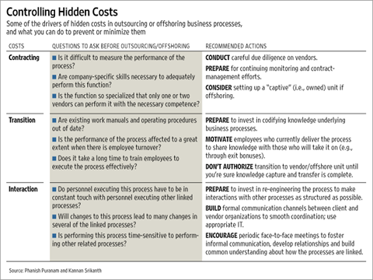
Figure 9.4: Indicators of transaction costs of outsourcing & offshoring

Lets consider the transaction hazards and sources of transaction costs in this situation:

First, Contracting costs: you should consider the costs of negotiating and reaching agreement on contractual deliverables, designing and implementing monitoring, measurement and dispute resolution mechanisms. Data secrecy and the possibility that you are effectively training a potential competitor should also be considered.

Second, Transition Costs: These are the costs of knowledge capture and transfer from your analysts to the new set of personnel in Bengaluru who will take over these activities. Since your unit has been in existence for a while, it is very likely that the analysts have developed significant tacit knowledge about how they go about their work, and this may be difficult if not impossible to transfer.

Third, Interaction Costs: These are the cost of managing interactions between the consultants who will remain in London and the new analysts who will be working from Bengaluru. Indeed, these may need to interact continuously, and the question for you is whether electronic communication will be sufficient to replace the current face-to-face interaction arrangements; or would you perhaps need to modify the way both your consultants and the analysts will work so that they can do so remotely.

Step IV: Decision
As you will see some of the costs above are of the nature of a large one time investment (e.g. transfer and process modification), whereas others may be recurring; some are easier to forecast the impact of and others are very hard to quantify. To help you reach a decision, two factors might be useful to consider:

First, the scale of the savings form offshoring. If you intend to scale up your analytics team to well beyond 10 people, then the gains from wage arbitrage will begin to payoff for costs of transition and interaction. Second, how much does your CEO trust the former classmate? If you cannot be confident about the competence of his team, issues around data confidentiality or his intentions in terms of potentially becoming a competitor (all forms of contracting costs), then you should be very wary of outsourcing in this case. At larger scale, but with the same concerns about contracting costs, you might consider a captive unit- a wholly owned subsidiary of your company that will enable you to gain the benefits of wage arbitrage without exposing you as much to contracting costs.

<APPLICATION ENDS>

Common mistakes to avoid in outsourcing

Ignoring transaction costs – Outsourcing often carries significant transaction costs, starting with finding a vendor and negotiating a contract. Then there's the expense of moving the operation from one location to another and subsequently keeping it in sync with the rest of the company. These hidden costs can eat significantly into the potential gains from transferring a formerly in-house activity into the hands of a specialist vendor. For instance, estimates suggest that close to 60-70% of wage differences are consumed in transaction costs when offshoring. Misleading analogies may create blind spots to these transaction costs. For instance, procuring stationary or buying power supply are in fact NOT good examples of outsourcing. The difference arises because you (probably) never made stationary or produced power in-house. When you outsource, you must move from a state where you made something in-house to one where you now procure. This adds significant complexity.

Misunderstanding the purpose of contracts – Unlike divestitures, outsourcing is not a one-time transaction, but an exchange that evolves over time, as competitive conditions and technology change. One reaction to this is to attempt to write complex contracts that protect both parties in all possible circumstances. This could be futile, as it will typically be impossible to take all contingencies into account. This does not mean that contracts are irrelevant. Managers should write a contract that ensures that all parties understand their roles and responsibilities, and then put in place a process for negotiating changes when necessary. Indeed the process of negotiating a contract will enable the client and vendor to understand the risks, rewards and interests for both sides.

Trying to outsource risk – Risk sharing between clients and vendors is one of the most contentious issues in outsourcing, leading to acrimonious negotiations and poor relationships. There is a very common—and reasonable—perception that vendors should bear greater liability for failure than regular, in-house employees who do a job. The client can and should specify standards that the vendor must meet, and penalties for falling short. However, it is unrealistic for the client to ask the vendor to take on unlimited liabilities or unlimited indemnities for failure. Legally the client will be liable to end customers in most cases anyway. You can only completely outsource risk to insurance companies.

Frequently Asked Questions
Q1: For the same component, companies sometimes use multiple vendors or they simultaneously make internally and buy externally. For instance, a maker of TV sets sources 80% of its TV screens from 3 different suppliers, but they also make about 20% of the volume internally. Should this “inefficiency” be removed and should the company move to a single vendor, either internal or external?
It could be efficient for a company to make and buy the same product.. The reasons include:
  - Benchmarking with external suppliers to improve efficiency of an internal supplier; using an internal supplier to understand external supplier's costs.
  - Retaining enough knowledge in-house to deal with vendors
  - Posing a credible threat of in-sourcing in the case of unsatisfactory supplier performance; or outsourcing if the internal division underperforms.
  - Balancing fluctuations in demand

These advantages have to be offset against inefficient internal production which will be typically of lower scale and possibly also of lower competence. You should recommend stopping internal production only if the factors above are not important.

Likewise, a company can benefit from using multiple external vendors. The reasons typically invoked include:
  - Lower risk by hedging against bankruptcy risk of any one supplier.
  - Increase competition between vendors as long as they can take on each other’s volumes , you can shift between them easily, and the coordination across vendors is relatively easy for you as client to execute.

Q2: It is sometimes argued that only standardized, commodity like processes should ever be outsourced. Is this true?
No. It is important not to confuse non-standardized processes as necessarily being the same as a process that you have a competitive advantage at. Because your company performs a process differently does not automatically mean that it performs it better. The process is core only if you do it differently and better in the sense that it gives you an advantage over competitors by enhancing customers’ willingness to pay or lowering suppliers’ willingness to sell.

In principle, any non-core activity (i.e., one which you have no advantage at) can be outsourced, subject to arrangements for managing transaction costs (interaction, transition and contracting costs). Standardized commodity like processes do typically generate lower transaction costs because (a) specifying contracts for them is easy and there are plenty of alternative vendors leading to low contracting costs, (b) interactions costs are likely to be low as processes are standardized and generic, and (c) finally transition costs are also likely to be low because standardized processes are likely to be well documented. However, if your organization has competence at managing contracting, interaction and transition costs because of experience at selecting and contracting with vendors, at transitioning and relocating processes within the company, or at managing vendor relationships or remote coordination with subsidiaries successfully, then it might be feasible to outsource even non-standardized commodity like processes, as long as specialist vendors can generate significant cost savings to offset these transaction costs.

Thus, what is feasible to outsource depends not only on the transaction costs, but also on the management competence of the outsourcer. So if your company has considerable management expertise at managing contracting, process redesign and relocation, and remote coordination, you also have a potentially larger set of non-core processes that could be considered for outsourcing. Since the converse is also true, this also warns against blindly imitating your peer companies in the industry as to what to outsource.

Academic background
Coase (1937) and Williamson (1975) are useful background reading for a reader with a deeper interst in transaction costs.
Coase, R. H. (1937). The nature of the firm. Economica, 4(16), 386–405.
Williamson, O. E. (1975). Markets and hierarchies: Analysis and anti-trust implications. New York, USA: The Free Press.

For more on the importance of ongoing relationships for aligning interests, see:
Vanneste, B. S., & Frank, D. H. (2014). Forgiveness in vertical relationships: Incentive and termination effects. Organization Science, 25(6), 1807-1822.

For more details on sources of transaction costs in the outsourcing/offshoring of services, see:
Srikanth, K., & Puranam, P. (2011). Integrating distributed work: Comparing task design, communication, and tacit coordination mechanisms. Strategic Management Journal, 32(8), 849-875.
Kotha, S., & Srikanth, K. (2013). Managing a global partnership model: Lessons from the Boeing 787 'Dreamliner' program. Global Strategy Journal, 3(1), 41-66.
Srikanth, K, & Puranam, P. (2014). The firm as a coordination system: Evidence from software services offshoring. Organization Science, 25(4), 1253-1271.

For meta-analyses related to outsourcing issues:
Geyskens, I., Steenkamp, J. B. E. M., & Kumar, N. (2006). Make, buy, or ally: A transaction cost theory meta-analysis. Academy of Management Journal, 49(3), 519-543.
Hawkins, T., Knipper, M. G., & Strutton, D. (2009). Opportunism in buyer-supplier relations: New insights from quantitative synthesis. Journal of Marketing Channels, 16(1), 43-75.

Puranam P. and Kannan S. (2007) Seven myths about outsourcing, Wall Street Journal, June 16th.

